ASSIGNMENT-1

Name-Rishabh Samra
Roll No - ee17s300

5 Fold Cross Validation

K Fold 1
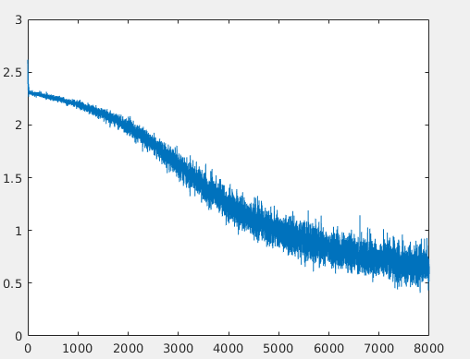
Train Loss:

Test Loss
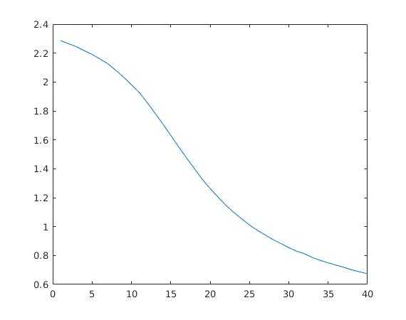

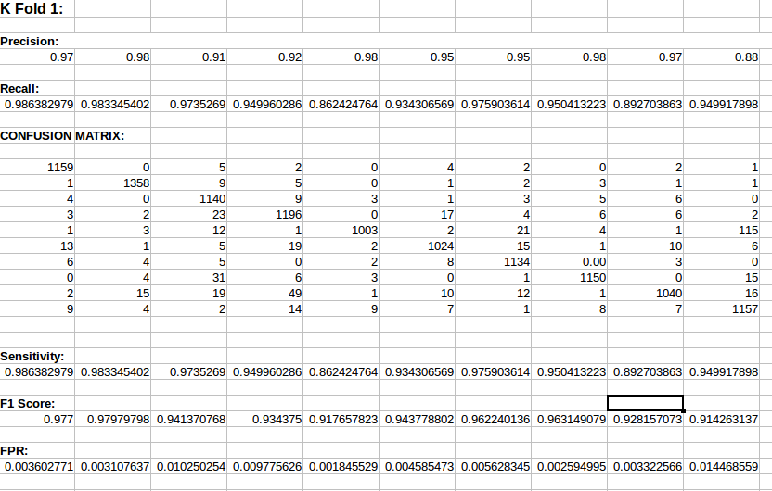
lr = 0.01 Test Accuracy: 82.28 %

K Fold 2:
Train Loss:

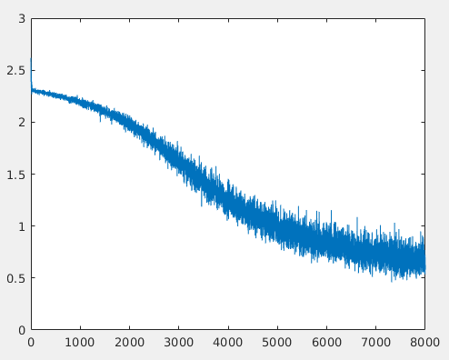

Test Loss:

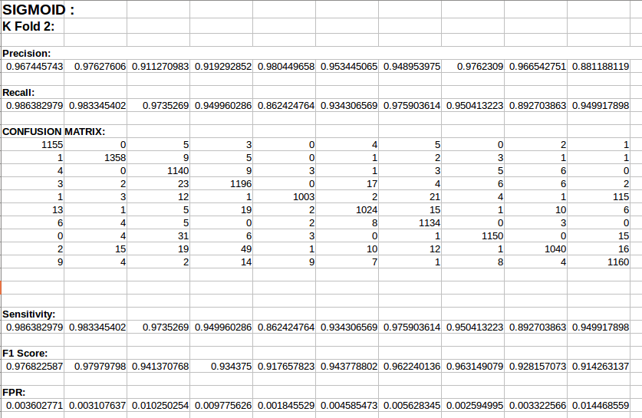

Accuracy: 84%
K FOLD 3:

Train Loss:
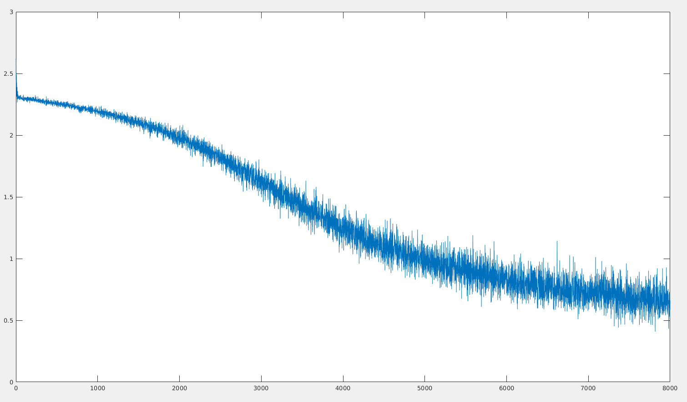

Test Loss:

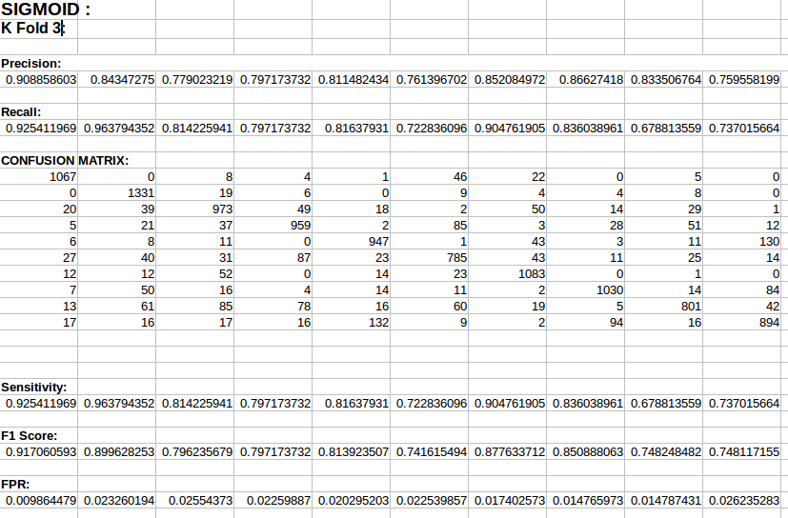
Accuracy = 82.25%

K Fold4:

Train Loss:

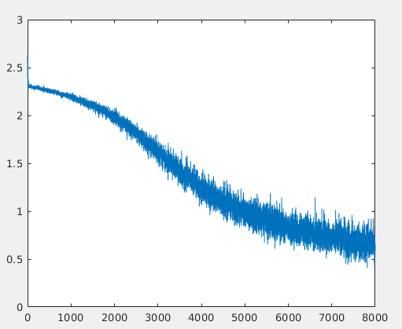

Test Loss:
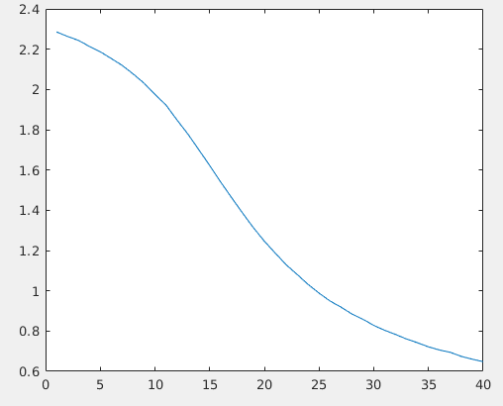

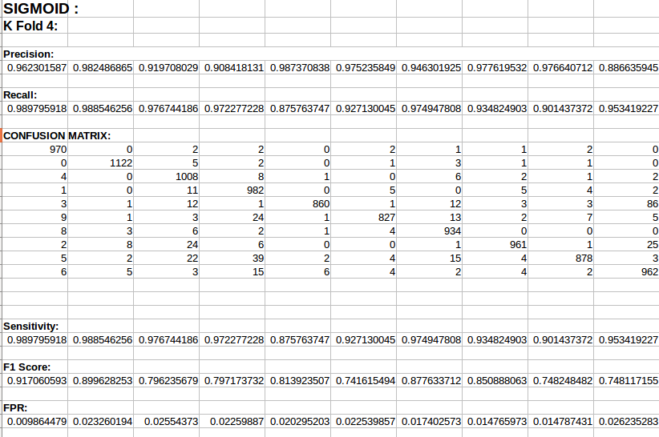

Accuracy = 81%
K Fold 5:
Train Loss:
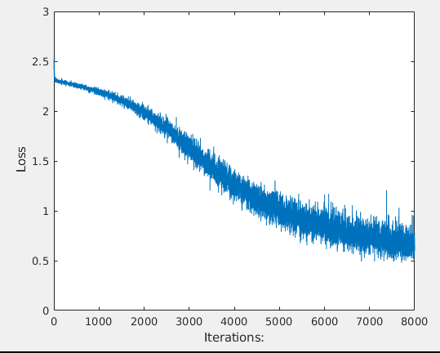

Test Loss:

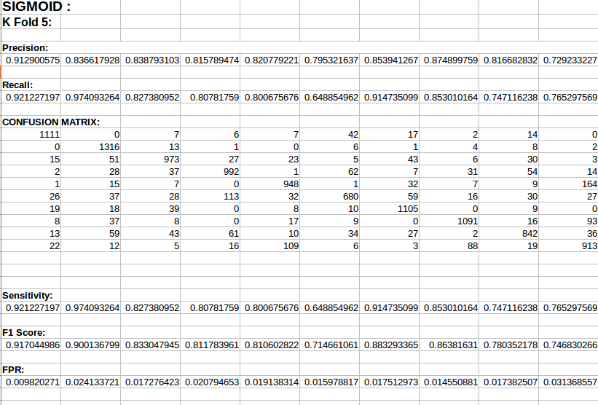
Accuracy:83.09%

Test Accuracy Calculated on 2 Fold:

Test Accuracy = 95.04%
Mean Loss= 0.1629

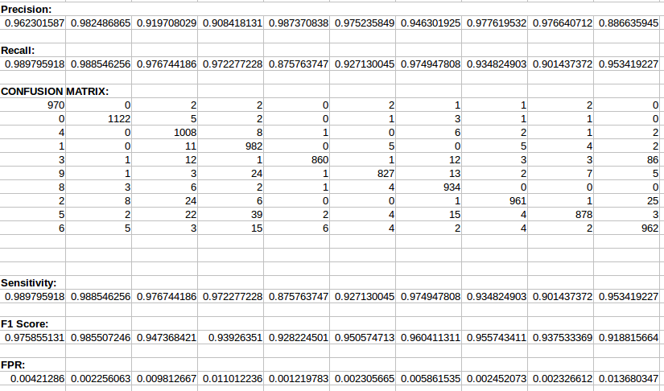

RELU :
Test Accuracy on Relu = 95.49%
Mean Loss = 0.2377
Train Loss:
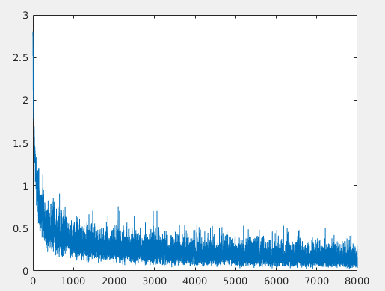
Kfold:
Relu
FOLD | ACCURACY(%)
1 | 95.25
2 | 94.92
3 | 95.0
4 | 95.4
5 | 94.89

Sigmoid:
FOLD | ACCURACY(%)
1 | 82.28
2 | 84.0
3 | 82.25
4 | 81.0
5 | 83.09
TEST LOSS:
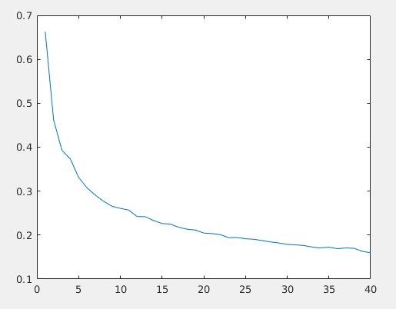

Regularization with Data Augmentation:

Accuracy = 95%
Train Loss:

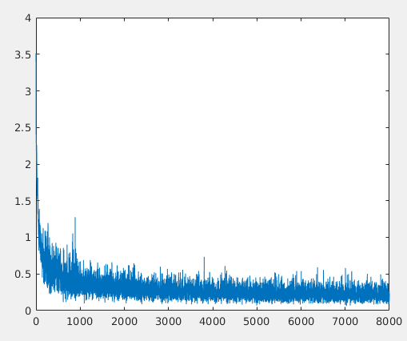

Test Loss:

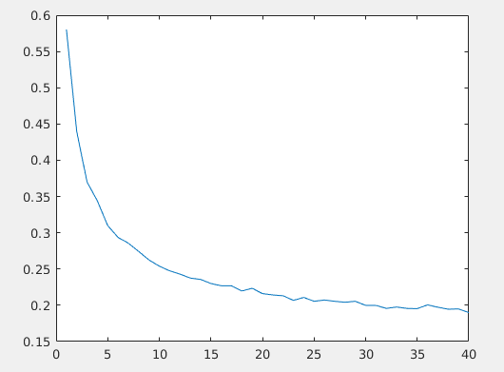

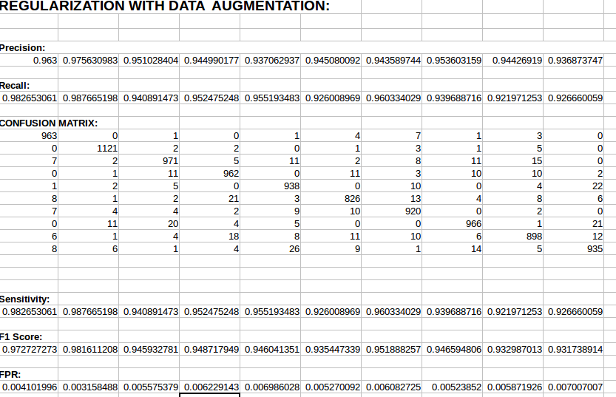

Top 3 Guesses:

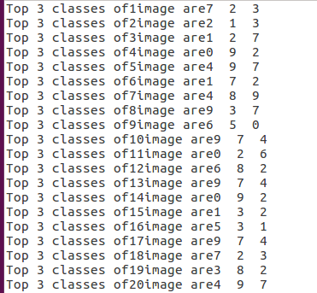

HOG:
Accuracy = 97.66%

Train Loss:

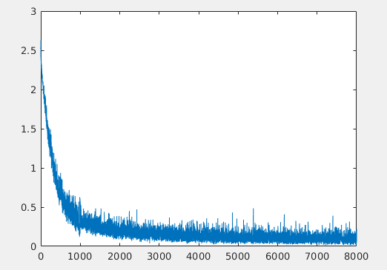

Test Loss:

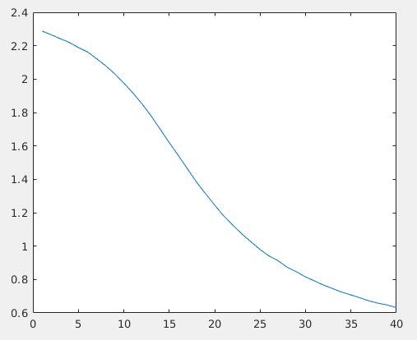

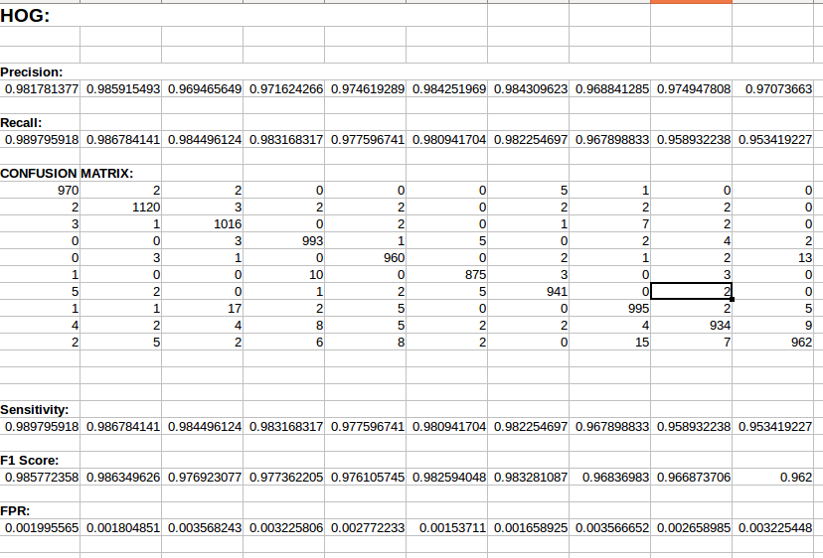
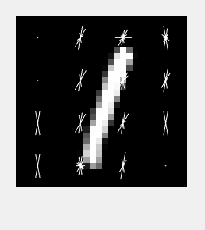

KNN:

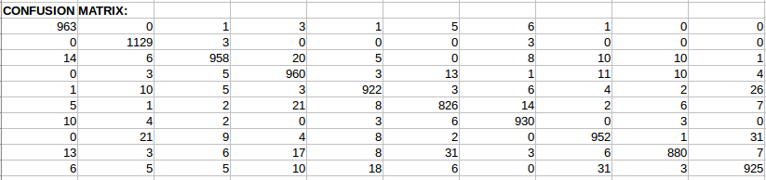

Accuracy = 94.45%

